TEST 8
LISTENING

PART 1 Questions 1-10
Complete the notes below.
Write ONE WORD ANDIOR A NUMBER for each answer.
Copying photos to digital format
Name of company: Picturerep
Requirements
• Maximum size of photos is 30 cm, minimum size 4 cm.
• Photos must not be in a 1 or an album.

Cost
• The cost for 360 photos is 2 £ (including one disk).
• Before the completed order is sent, 3 is required.

Services included in the price
• Photos can be placed in a folder, e.g. with the name 4
• The 5 and contrast can be improved if necessary.
• Photos which are very fragile will be scanned by 6

Special restore service (costs extra)
• It may be possible to remove an object from a photo, or change the
7
• A photo which is not correctly in 8 cannot be fixed.

Other information
• Orders are completed within 9
• Send the photos in a box (not 10 ).

PART 2 Questions 11 – 14
Choose the correct letter, A, B or C.

Oniton Hall
11 Many past owners made changes to
A the gardens.
B the house.
C the farm.
12 Sir Edward Downes built Oniton Hall because he wanted
A a place for discussing politics.
B a place to display his wealth.
C a place for artists and writers.
13 Visitors can learn about the work of servants in the past from
A audio guides.
B photographs.
C people in costume.
14 What is new for children at Onion Hall?
A clothes for dressing up
B mini tractors
C the adventure playground

Questions 15-20
Which activity is offered at each of the following locations on the farm?
Choose SIX answers from the box and write the correct letter, A-H, next to Questions 15-20.
Activities
A shopping
B watching cows being milked
C seeing old farming equipment
D eating and drinking
E starting a trip
F seeing rare breeds of animals
G helping to look after animals
H using farming tools
Locations on the farm
15 dairy ………………….
16 large barn ………………….
17 small barn ………………….
18 stables ………………….
19 shed ………………….
20 parkland ………………….

PART 3 Questions 21-30
Questions 21-24
Choose the correct letter, A, B or C.
21 Why do the students think the Laki eruption of 1783 is so important?
A It was the most severe eruption in modern times.
B It led to the formal study of volcanoes.
C It had a profound effect on society.
22 What surprised Adam about observations made at the time?
A the number of places producing them
B the contradictions in them
C the lack of scientific data to support them
23 According to Michelle, what did the contemporary sources say about the Laki haze?
A People thought it was similar to ordinary fog.
B It was associated with health issues.
C It completely blocked out the sun for weeks.
24 Adam corrects Michelle when she claims that Benjamin Franklin
A came to the wrong conclusion about the cause of the haze.
B was the first to identify the reason for the haze.
C supported the opinions of other observers about the haze.
Questions 25 and 26
Choose TWO letters, A-E.
Which TWO issues following the Laki eruption surprised the students?
A how widespread the effects were
B how long-lasting the effects were
C the number of deaths it caused
D the speed at which the volcanic ash cloud spread
E how people ignored the warning signs
Questions 27-30
What comment do the students make about the impact of the Laki eruption on the following countries?
Choose FOUR answers from the box and write the correct letter, A-F, next to Questions 27-30.

Comments
A This country suffered the most severe loss of life.
B The impact on agriculture was predictable.
C There was a significant increase in deaths of young people.
D Animals suffered from a sickness.
E This country saw the highest rise in food prices in the world.
F It caused a particularly harsh winter.

Countries

27 Iceland

28 Egypt

29 UK

30 USA

PART 4 Questions 31–40
Complete the notes below.
Write ONE WORD AND/OR A NUMBER for each answer.
Concerts in university arts festival
Concert 1
- Australian composer: Liza Lim
- studied piano and 31 .............................. before turning to composition
- performers and festivals around the world have given her a lot of commissions
- compositions show a great deal of 32 .............................. and are drawn from various cultural sources
- her music is very expressive and also 33 ..............................
- festival will include her 34 .............................. called The Oresteia
- Lim described the sounds in The Oresteia as 35 ..............................
- British composers: Ralph Vaughan Williams, Frederick Delius
Concert 2
- British composers: Benjamin Britten, Judith Weir
- Australian composer: Ross Edwards
- festival will include The Tower of Remoteness, inspired by nature
- The Tower of Remoteness is performed by piano and 36 ..............................
- compositions include music for children
- celebrates Australia's cultural 37 ..............................
Concert 3
- Australian composer: Carl Vine
- played cornet then piano
- studied 38 .............................. before studying music
- worked in Sydney as a pianist and composer
- became well known as composer of music for 39 ..............................
- festival will include his music for the 1996 40 ..............................
- British composers: Edward Elgar, Thomas Adès

READING

READING PASSAGE 1
You should spend about 20 minutes on Questions 1-13, which are based on Reading Passage 1 below.

The White Horse of Uffington
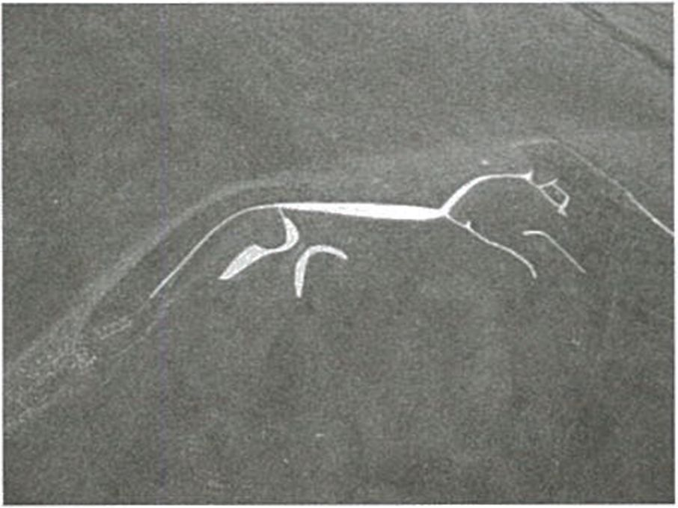
The cutting of huge figures or ‘geoglyphs’ into the earth of English hillsides has taken place for more than 3,000 years. There are 56 hill figures scattered around England, with the vast majority on the chalk downlands of the country’s southern counties. The figures include giants, horses, crosses and regimental badges. Although the majority of these geoglyphs date within the last 300 years or so, there are one or two that are much older.

The most famous of these figures is perhaps also the most mysterious - the Uffington White Horse in Oxfordshire. The White Horse has recently been re-dated and shown to be even older than its previously assigned ancient pre-Roman Iron Age date. More controversial is the date of the enigmatic Long Man of Wilmington in Sussex. While many historians are convinced the figure is prehistoric, others believe that it was the work of an artistic monk from a nearby priory and was created between the 11th and 15th centuries.

The method of cutting these huge figures was simply to remove the overlying grass to reveal the gleaming white chalk below. However, the grass would soon grow over the geoglyph again unless it was regularly cleaned or scoured by a fairly large team of people. One reason that the vast majority of hill figures have disappeared is that when the traditions associated with the figures faded, people no longer bothered or remembered to clear away the grass to expose the chalk outline. Furthermore, over hundreds of years the outlines would sometimes change due to people not always cutting in exactly the same place, thus creating a different shape to the original geoglyph. The fact that any ancient hill figures survive at all in England today is testament to the strength and continuity of local customs and beliefs which, in one case at least, must stretch back over millennia.

The Uffington White Horse is a unique, stylised representation of a horse consisting of a long, sleek back, thin disjointed legs, a streaming tail, and a bird-like beaked head. The elegant creature almost melts into the landscape. The horse is situated 2.5 km from Uffington village on a steep slope close to the Late Bronze Age (c. 7th century BCE) hillfort of Uffington Castle and below the Ridgeway, a long-distance Neolithic track.

The Uffington Horse is also surrounded by Bronze Age burial mounds. It is not far from the Bronze Age cemetery of Lambourn Seven Barrows, which consists of more than 30 well-preserved burial mounds. The carving has been placed in such a way as to make it extremely difficult to see from close quarters, and like many geoglyphs is best appreciated from the air. Nevertheless, there are certain areas of the Vale of the White Horse, the valley containing and named after the enigmatic creature, from which an adequate impression may be gained. Indeed, on a clear day the carving can be seen from up to 30 km away.

The earliest evidence of a horse at Uffington is from the 1070s CE when ‘White Horse Hill’ is mentioned in documents from the nearby Abbey of Abingdon, and the first reference to the horse itself is soon after, in 1190 CE. However, the carving is believed to date back much further than that. Due to the similarity of the Uffington White Horse to the stylised depictions of horses on 1st century BCE coins, it had been thought that the creature must also date to that period.

However, in 1995 Optically Stimulated Luminescence (OSL) testing was carried out by the Oxford Archaeological Unit on soil from two of the lower layers of the horse’s body, and from another cut near the base. The result was a date for the horse’s construction somewhere between 1400 and 600 BCE - in other words, it had a Late Bronze Age or Early Iron Age origin.

The latter end of this date range would tie the carving of the horse in with occupation of the nearby Uffington hillfort, indicating that it may represent a tribal emblem marking the land of the inhabitants of the hillfort. Alternatively, the carving may have been carried out during a Bronze or Iron Age ritual. Some researchers see the horse as representing the Celtic horse goddess Epona, who was worshipped as a protector of horses, and for her associations with fertility. However, the cult of Epona was not imported from Gaul (France) until around the first century CE. This date is at least six centuries after the Uffington Horse was probably carved. Nevertheless, the horse had great ritual and economic significance during the Bronze and Iron Ages, as attested by its depictions on jewellery and other metal objects. It is possible that the carving represents a goddess in native mythology, such as Rhiannon, described in later Welsh mythology as a beautiful woman dressed in gold and riding a white horse.

The fact that geoglyphs can disappear easily, along with their associated rituals and meaning, indicates that they were never intended to be anything more than temporary gestures. But this does not lessen their importance. These giant carvings are a fascinating glimpse into the minds of their creators and how they viewed the landscape in which they lived.

Questions 1-8
Do the following statements agree with the information given in Reading Passage 1?
In boxes 1-8 on your answer sheet, write
TRUE if the statement agrees with the information
FALSE if the statement contradicts the information
NOT GIVEN if there is no information on this

1 Most geoglyphs in England are located in a particular area of the country.
2 There are more geoglyphs in the shape of a horse than any other creature.
3 A recent dating of the Uffington White Horse indicates that people were mistaken about its age.
4 Historians have come to an agreement about the origins of the Long Man of Wilmington.
5 Geoglyphs were created by people placing white chalk on the hillside.
6 Many geoglyphs in England are no longer visible.
7 The shape of some geoglyphs has been altered over time.
8 The fame of the Uffington White Horse is due to its size.

Questions 9-13
Complete the notes below.
Choose ONE WORD ONLY from the passage for each answer.
Write your answers in boxes 9-13 on your answer sheet.
The Uffington White Horse

The location of the Uffington White Horse:
• a distance of 2.5 km from Uffington village
• near an ancient road known as the 9
• close to an ancient cemetery that has a number of burial mounds

Dating the Uffington White Horse:
• first reference to White Horse Hill appears in 10 from
the 1070s
• horses shown on coins from the period 100 BCE - 1 BCE are similar in appearance
• according to analysis of the surrounding 11 , the Horse is
Late Bronze Age / Early Iron Age

Possible reasons for creation of the Uffington White Horse:
• an emblem to indicate land ownership
• formed part of an ancient ritual
• was a representation of goddess Epona - associated with protection of horses
and 12
• was a representation of a Welsh goddess called 13

READING PASSAGE 2
You should spend about 20 minutes on Questions 14-26 which are based on Reading Passage 2 below.

A second attempt at domesticating the tomato
A
It took at least 3,000 years for humans to learn how to domesticate the wild tomato and cultivate it for food. Now two separate teams in Brazil and China have done it all over again in less than three years. And they have done it better in some ways, as the re-domesticated tomatoes are more nutritious than the ones we eat at present.
This approach relies on the revolutionary CRISPR genome editing technique, in which changes are deliberately made to the DNA of a living cell, allowing genetic material to be added, removed or altered. The technique could not only improve existing crops, but could also be used to turn thousands of wild plants into useful and appealing foods. In fact, a third team in the US has already begun to do this with a relative of the tomato called the groundcherry.
This fast-track domestication could help make the world’s food supply healthier and far more resistant to diseases, such as the rust fungus devastating wheat crops.
‘This could transform what we eat,’ says Jorg Kudla at the University of Munster in Germany, a member of the Brazilian team. ‘There are 50,000 edible plants in the world, but 90 percent of our energy comes from just 15 crops.’
‘We can now mimic the known domestication course of major crops like rice, maize, sorghum or others,’ says Caixia Gao of the Chinese Academy of Sciences in Beijing. ‘Then we might try to domesticate plants that have never been domesticated.’
B
Wild tomatoes, which are native to the Andes region in South America, produce pea-sized fruits. Over many generations, peoples such as the Aztecs and Incas transformed the plant by selecting and breeding plants with mutations* in their genetic structure, which resulted in desirable traits such as larger fruit.
But every time a single plant with a mutation is taken from a larger population for breeding, much genetic diversity is lost. And sometimes the desirable mutations come with less desirable traits. For instance, the tomato strains grown for supermarkets have lost much of their flavour.
By comparing the genomes of modern plants to those of their wild relatives, biologists have been working out what genetic changes occurred as plants were domesticated. The teams in Brazil and China have now used this knowledge to reintroduce these changes from scratch while maintaining or even enhancing the desirable traits of wild strains.
C
Kudla’s team made six changes altogether. For instance, they tripled the size of fruit by editing a gene called FRUIT WEIGHT, and increased the number of tomatoes per truss by editing another called MULTIFLORA.
While the historical domestication of tomatoes reduced levels of the red pigment lycopene – thought to have potential health benefits – the team in Brazil managed to boost it instead. The wild tomato has twice as much lycopene as cultivated ones; the newly domesticated one has five times as much.
‘They are quite tasty,’ says Kudla. ‘A little bit strong. And very aromatic.’
The team in China re-domesticated several strains of wild tomatoes with desirable traits lost in domesticated tomatoes. In this way they managed to create a strain resistant to a common disease called bacterial spot race, which can devastate yields. They also created another strain that is more salt tolerant – and has higher levels of vitamin C.
D
Meanwhile, Joyce Van Eck at the Boyce Thompson Institute in New York state decided to use the same approach to domesticate the groundcherry or goldenberry (Physalis pruinosa) for the first time. This fruit looks similar to the closely related Cape gooseberry (Physalis peruviana).
Groundcherries are already sold to a limited extent in the US but they are hard to produce because the plant has a sprawling growth habit and the small fruits fall off the branches when ripe. Van Eck’s team has edited the plants to increase fruit size, make their growth more compact and to stop fruits dropping. ‘There’s potential for this to be a commercial crop,’ says Van Eck. But she adds that taking the work further would be expensive because of the need to pay for a licence for the CRISPR technology and get regulatory approval.
E
This approach could boost the use of many obscure plants, says Jonathan Jones of the Sainsbury Lab in the UK. But it will be hard for new foods to grow so popular with farmers and consumers that they become new staple crops, he thinks.
The three teams already have their eye on other plants that could be ‘catapulted into the mainstream’, including foxtail, oat-grass and cowpea. By choosing wild plants that are drought or heat tolerant, says Gao, we could create crops that will thrive even as the planet warms.
But Kudla didn’t want to reveal which species were in his team’s sights, because CRISPR has made the process so easy. ‘Any one with the right skills could go to their lab and do this.’
———————-
* mutations: changes in an organism’s genetic structure that can be passed down to later generations
Questions 14-18
Reading Passage 2 has five paragraphs, A-E.
Which section contains the following information?
Write the correct letter, A-E, in boxes 14-18 on your answer sheet.
NB You may use any letter more than once.
14 a reference to a type of tomato that can resist a dangerous infection.
15 an explanation of how problems can arise from focusing only on a certain type of tomato plant.
16 a number of examples of plants that are not cultivated at present but could be useful as food sources.
17 a comparison between the early domestication of the tomato and more recent research
18 a personal reaction to the flavour of a tomato that has been genetically edited

Questions 19-23
Look at the following statements (Questions 19-23) and the list of researchers below.
Match each statement with the correct researcher, A-D.
Write the correct letter, A-D, in boxes 19-23 on your answer sheet.
NB You may use any letter more than once.
19 Domestication of certain plants could allow them to adapt to future environmental challenges.
20 The idea of growing and eating unusual plants may not be accepted on a large scale.
21 It is not advisable for the future direction of certain research to be made public.
22 Present efforts to domesticate one wild fruit are limited by the costs involved.
23 Humans only make use of a small proportion of the plant food available on Earth.
List of Researchers
A Jorg Kudla
B Caixia Gao
C Joyce Van Eck
D Jonathan Jones

Questions 24-26
Complete the sentences below.
Choose ONE WORD ONLY from the passage for each answer.
Write your answers in boxes 24-26 on your answer sheet.
24 An undesirable trait such as loss of ……………………… may be caused by a mutation in a tomato gene.
25 By modifying one gene in a tomato plant, researchers made the tomato three times its original ………………………
26 A type of tomato which was not badly affected by ………………………, and was rich in vitamin C, was produced by a team of researchers in China.
Advertisements

READING PASSAGE 3
You should spend about 20 minutes on Questions 27-40, which are based on Reading Passage 3 below.
An ideal city
Leonardo da Vinci’s ideal city was centuries ahead of its time
The word ‘genius’ is universally associated with the name of Leonardo da Vinci. A true Renaissance man, he embodied scientific spirit, artistic talent and humanist sensibilities. Five hundred years have passed since Leonardo died in his home at Château du Clos Lucé, outside Tours, France. Yet far from fading into insignificance, his thinking has carried down the centuries and still surprises today.

The Renaissance marked the transition from the 15th century to modernity and took place after the spread of the plague in the 14th century, which caused a global crisis resulting in some 200 million deaths across Europe and Asia. Today, the world is on the cusp of a climate crisis, which is predicted to cause widespread displacement, extinctions and death, if left unaddressed. Then, as now, radical solutions were called for to revolutionise the way people lived and safeguard humanity against catastrophe.

Around 1486 - after a pestilence that killed half the population in Milan, Italy -Leonardo turned his thoughts to urban planning problems. Following a typical Renaissance trend, he began to work on an ‘ideal city’ project, which - due to its excessive costs - would remain unfulfilled. Yet given that unsustainable urban models are a key cause of global climate change today, it’s only natural to wonder how Leonardo might have changed the shape of modem cities.

Although the Renaissance is renowned as an era of incredible progress in art and architecture, it is rarely noted that the 15th century also marked the birth of urbanism as a true academic discipline. The rigour and method behind the conscious conception of a city had been largely missing in Western thought until the moment when prominent Renaissance men pushed forward large-scale urban projects in Italy, such as the reconfiguration of the town of Pienza and the expansion of the city of Ferrara. These works surely inspired Leonardo’s decision to rethink the design of medieval cities, with their winding and overcrowded streets and with houses piled against one another.

It is not easy to identify a coordinated vision of Leonardo’s ideal city because of his disordered way of working with notes and sketches. But from the largest collection of Leonardo’s papers ever assembled, a series of innovative thoughts can be reconstructed regarding the foundation of a new city along the Ticino River, which runs from Switzerland into Italy and is 248 kilometres long. He designed the city for the easy transport of goods and clean urban spaces, and he wanted a comfortable and spacious city, with well-ordered streets and architecture. He recommended ‘high, strong walls’, with ‘towers and battlements of all necessary and pleasant beauty’.

His plans for a modem and ‘rational’ city were consistent with Renaissance ideals. But, in keeping with his personality, Leonardo included several innovations in his urban design. Leonardo wanted the city to be built on several levels, linked with vertical outdoor staircases. This design can be seen in some of today’s high-rise buildings but was unconventional at the time. Indeed, this idea of taking full advantage of the interior spaces wasn’t implemented until the 1920s and 1930s, with the birth of the Modernist movement.

While in the upper layers of the city, people could walk undisturbed between elegant palaces and streets, the lower layer was the place for services, trade, transport and industry. But the true originality of Leonardo’s vision was its fusion of architecture and engineering. Leonardo designed extensive hydraulic plants to create artificial canals throughout the city. The canals, regulated by clocks and basins, were supposed to make it easier for boats to navigate inland. Leonardo also thought that the width of the streets ought to match the average height of the adjacent houses: a rule still followed in many contemporary cities across Italy, to allow access to sun and reduce the risk of damage from earthquakes.

Although some of these features existed in Roman cities, before Leonardo’s drawings there had never been a multi-level, compact modem city which was thoroughly technically conceived. Indeed, it wasn’t until the 19th century that some of his ideas were applied. For example, the subdivision of the city by function - with services and infrastructures located in the lower levels and wide and well-ventilated boulevards and walkways above for residents - is an idea that can be found in Georges-Eugène Haussmann’s renovation of Paris under Emperor Napoleon III between 1853 and 1870.
Today, Leonardo’s ideas are not simply valid, they actually suggest a way forward for urban planning. Many scholars think that the compact city, built upwards instead of outwards, integrated with nature (especially water systems), with efficient transport infrastructure, could help modem cities become more efficient and sustainable. This is yet another reason why Leonardo was aligned so closely with modem urban planning and centuries ahead of his time.

Questions 27-33
Do the following statements agree with the information given in Reading Passage 3?
In boxes 27-33 on your answer sheet, write
TRUE if the statement agrees with the information
FALSE if the statement contradicts the information
NOT GIVEN if there is no information on this

27 People first referred to Leonardo da Vinci as a genius 500 years ago.
28 The current climate crisis is predicted to cause more deaths than the plague.

29 Some of the challenges we face today can be compared to those of earlier times.
30 Leonardo da Vinci’s ‘ideal city’ was constructed in the 15th century.
31 Poor town planning is a major contributor to climate change.
32 In Renaissance times, local people fought
against the changes to Pienza and Ferrara.
33 Leonardo da Vinci kept a neat, organised record of his designs.
Questions 34—40
Complete the summary below.
Choose ONE WORD ONLY from the passage for each answer.
Write your answers in boxes 34-40 on your answer sheet.
Leonardo da Vinci’s ideal city
A collection of Leonardo da Vinci’s paperwork reveals his design of a new city beside the Ticino River. This was to provide better 34……….. for trade and a less polluted environment. Although Leonardo da Vinci’s city shared many of the ideals of his time, some of his innovations were considered unconventional in their design. They included features that can be seen in some tower blocks today, such as 35……….. on the exterior of a building.

Leonardo da Vinci wasn’t only an architect. His expertise in 36 ……….. was evident in his plans for artificial canals within his ideal city. He also believed that the height of houses should relate to the width of streets in case earthquakes occurred. The design of many cities in Italy today follows this 37………..

While some cities from 38……….. times have aspects that can also be found in Leonardo’s designs, his ideas weren’t put into practice until long after his death. 39……….. is one example of a city that was redesigned in the 19th century in the way that Leonardo had envisaged. His ideas are also relevant to today’s world, where building 40……….. no longer seems to be the best approach.

WRITING

WRITING TASK 1
You should spend about 20 minutes on this task.
The diagram below shows the manufacturing process for making sugar from sugar cane.
Summarise the information by selecting and reporting the main features, and make comparisons where relevant.

Write at least 150 words.
How sugar is produced from sugar cane

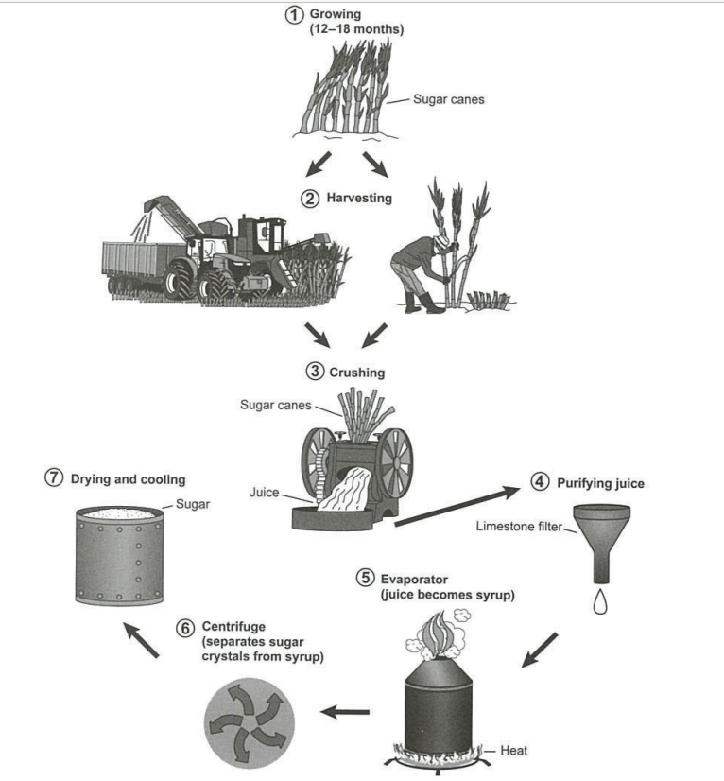

WRITING TASK 2
You should spend about 40 minutes on this task.
Write about the following topic:

Some children spend hours every day on their smartphones.

Why is this the case? Do you think this is a positive or a negative development?

Give reasons for your answer and include any relevant examples from your own knowledge or experience.
Write at least 250 words.

SPEAKING

PART 1
The examiner asks you about yourself, your home, work or studies and other familiar topics.
EXAMPLE
Flowers and plants
• Do you have a favourite flower or plant? [Why/Why not?]
• What kinds of flowers and plants grow near where you live? [Why/Why not?]
• Is it important to you to have flowers and plants in your home? [Why/Why not?]
• Have you ever bought flowers for someone else? [Why/Why not?]

PART 2
You will have to talk about the topic for one to two minutes. You have one minute to think about what you are going to say. You can make some notes to help you if you wish
Describe a big city you would like to visit.
You should say:
- which big city you would like to visit
- how you would travel there
- what you would do there
and explain why you would like to visit this big city.

PART 3
Discussion topics:
Visiting cities on holiday
- What are the most interesting things to do while visiting cities on holiday?
- Why can it be expensive to visit cities on holiday?
- Do you think it is better to visit cities alone or in a group with friends?
The growth of cities
- Why have cities increased in size in recent years?
- What are the challenges created by ever-growing cities?
- In what ways do you think cities of the future will be different to cities today?

lron Age: a period (in Britain 800 BCE - 43 CE) that is characterised by the use of iron tools
Bronze Age: a period (in Britain c. 2,500 BCE - 800 BCE) that is characterised by the development of bronze tools
Neolithic: a period (in Britain c. 4,000 BCE - c. 2,500 BCE) that is significant for the spread of agricultural practices, and the use of stone tools
Celtic: an ancient people who migrated from Europe to Britain before the Romans

